OCTOBER ‘21

GLOBAL IDD DAY




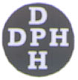
English Version of Tamil Booklet printed for Global IDD Day 2001

Government of Tamil Nadu
Department of Public Health and
Preventive Medicine, Chennai-6

GLOBAL IDD DAY-OCTOBER ‘21

To create awareness on IDD, the day October 21 is observed as Global IDD Day by WHO every year. Like Vitamins and iron iodine is a micronutrient, which is required in small amounts by the body. Nowadays IDD prevails all over the world and affects I.Q of younger generation. In our country, iodised salt is being used to combat this Iodine Deficiency Disorder. Few questions and answers about IDD and iodine are given below:

Q. Iodine is a micronutrient. What way it is needed by our body?

Without iodine, the thyroid gland cannot synthesise the hormone thyroxin. Thyroxin is essential for normal body growth, brain development and metabolic functions.

Q. What are the signs and symptoms of IDD?
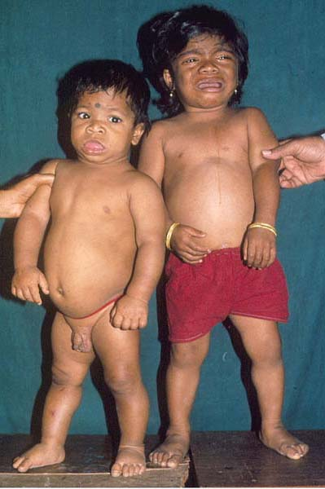
IDD of the pregnant mother affects her foetus. The foetus may have retarded physical growth and mental development. There may be premature delivery or foetal death. The live born babies may be affected by the condition known as “cretinism”.

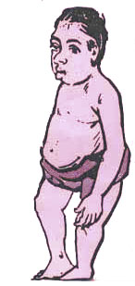
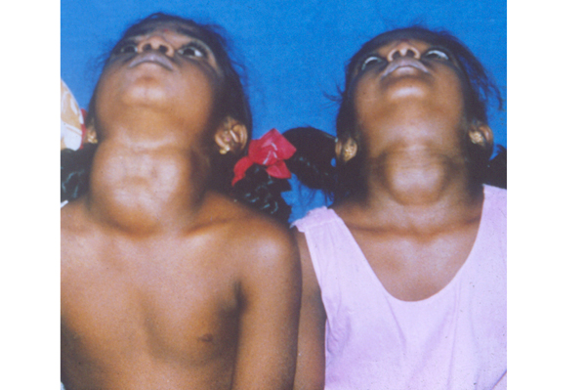
Cretin babies have retarded physical growth and brain development. They are short. When normal children are playful, they are lethargic and dull. Tongue is often protruded and there is dribbling of saliva. The I.Q. of the cretin babies may be reduced by 11-13 points than those of normal babies. Some babies may have associated conditions like squint; limping and deaf mutism.
24 years old Cretin Male

Grown up children may show reduced school performance due to Iodine Deficiency Disorder. They have puffiness of face, so that nasal bridge is often depressed. This condition is called Myxoedema.
Goiter cases of 13 year old female children
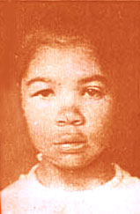
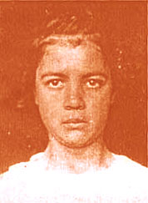
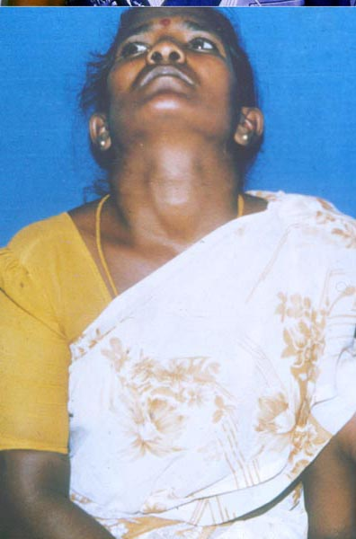
IDD leads to thyroid gland swelling in adults. This is called goitre. Though it is seen commonly among middle-aged women it affects all age groups and both sexes. Along with goitre some people may complain weight gain in spite of loss of appetite, dry skin, dull and lethargy. Women are prone for menstrual disturbances, pregnancy wastage and lactational insufficiency.
Myxoedema in 10-year-old girl
Same girl after treatment and six months continuous use of iodised salt

Q. Is there any treatment available for IDD?

Cretinism & brain damage due to IDD are irreversible conditions and cannot be cured by treatment. Other diseases like Myxoedema may be cured by continuous Utilisation of Iodised salt. There are thyroid function tests and hormonal therapy available to treat these conditions.
Woman with goitre

Q. When there is no goitre, can we say there is no Iodine Deficiency Disorder in the community?

No, Goiter is only the tip of iceberg, so it is visible. But the disease spectrum of Iodine Deficiency Disorder involves so many defects directly affecting the mankind right from birth. The important ill effect of IDD is diminution of IQ. The low IQ of one community may be recognized only when it is compared with that of another community. Like wise the invisible disease spectrum of IDD are many. So we cannot say when there is no goiter there is no IDD in the community.

Q. Does the Iodine deficiency prevail in Tamil Nadu?

Yes. Iodine deficiency prevails in all districts of Tamil Nadu.

Q. What are the nutritious foods for Iodine? Some people of Tamil Nadu believes the vegetable” Ladies finger” has got increased amount of Iodine. Is it correct?

The important source of Iodine is soil. From the soil it concentrates on plants. From the vegetation it goes to animals and human beings. When the soil is rich in iodine, not only the vegetable Ladies finger, all other vegetables have abundant stock of iodine. If the soil lacks iodine, automatically the vegetables will also lack iodine. In some vegetables such as Cauliflower, Cabbage and turnip there is a substance known as goitrogen. It prevents the availability of iodine to the thyroid glands.

Q. Is sea fish the rich source of iodine?

Iodine is plenty in sea fish, crab and some species of algae. But in sea fish iodine is concentrated on its head. Usually our people have the habit of cutting the fish head and cooking other parts. So iodine may not be available to the body.

Q. Why can’t we combat IDD by taking much more sea fish in our diet?

Taking much more sea fish in our diet is good. But some people may object it. More over this habit alone cannot prevent Iodine Deficiency Disorder. The only effective solution for IDD now –a-days is iodised salt.

Q. Some people usually take more salt in their diet. If they use iodised salt will it lead to increased production of thyroxin hormone?

No. Data's are available about the upper limit of salt usage by the people of different countries. The maximum limit of iodine tolerable to our body is also calculated. By correlating these factors using iodised salt according to Indian food custom would not lead to increased thyroxin secretion. More over whatever the level of iodine in our body, thyroid gland takes only the required amount. The excess iodine will be kept in the circulation for future utilisation.

Q. Can the patients of hyper thyroidism (Status of increased thyroxin secretion) use iodised salt?

Yes they can use. The causes of hyper thyroidism include hormonal imbalance and other reasons. But it is not that iodine in the iodised salt leads to hyper thyroidism.

Q. How can we find out iodine in our edible salt?

We have starch solution test to find out the iodine in the edible salt. Starch is the indicator and when it is applied on salt it changes its colour from light blue to indigo according to the amount of iodine present in the edible salt. There won’t be any colour change if the salt does not contain iodine. The required amount of iodine at the manufacturer level should not be less than 30 ppm and at consumer level it should not be less than 15 ppm.
Q. How can we keep iodised salt?

It is better to add iodised salt in the later part of cooking through which 30% loss of iodine may be prevented. Iodised salt can be kept in a closed container, away from strong sunlight and humidity. Even the crystal salt can be iodised. The word” iodised salt “ is written over the salt pocket. Some times the logo of “smiling sun” is also present.

Q. In our community my neighbours and myself use iodised salt. So in our area there won’t be Iodine Deficiency Disorder. Am I correct?

No. In IDD endemic areas 95% of people have to use iodised salt to cease IDD as a public health problem. But in our state only 40% of people use iodised salt.
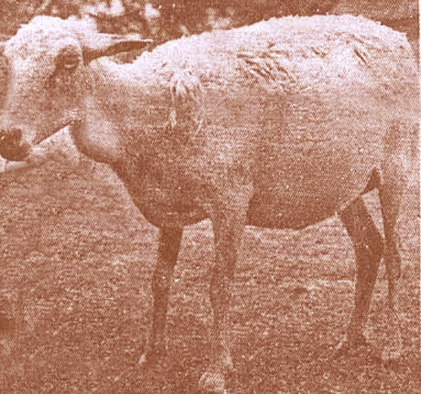
Q. While using iodised salt years together, is there any side effect?

No, because iodine is continuously needed by our body. Salt is always being taken in a small quantity continuously. As Iodine is incorporated in the edible salt it is also taken in a small quantity regularly and by all sectors of people. This way the required amount of iodine is met. So while using iodised salt years together there is no side effect. One can avert cretin births by using iodised salt continuously for one year. By using iodised salt the size of the goiter will be reduced. The important unwanted effect of IDD is diminution of I.Q. We should not give chances for that.
A goat with goitre

Please check your kitchen,
whether it contains iodised salt or not.

